Population Growth

**Question No. 1**

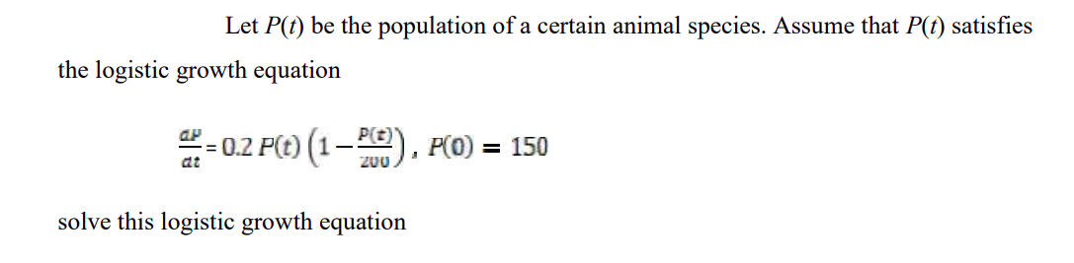

**Question No. 2**

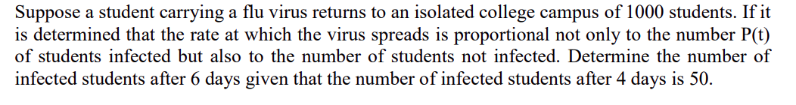

**Question No. 3**

A Falling Object with Air Resistance

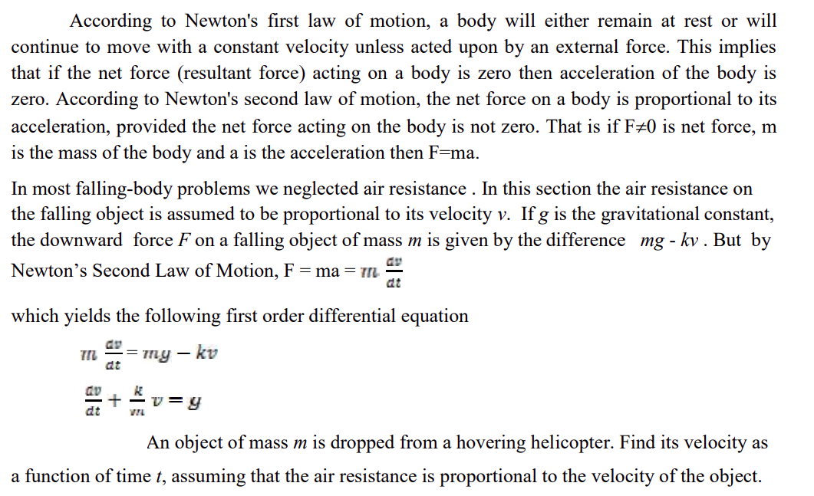

Question No. 4

